The Presentation of Media-rich Collections of
Culture Heritage in the Age of Digital Reproduction

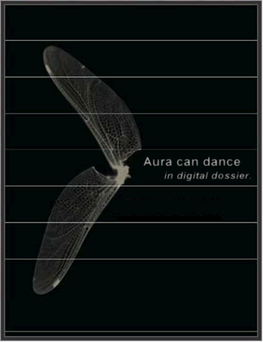

Yiwen Wang
Master’s thesis
Yiwen Wang
Student number: 1488538
Email: ywang@few.vu.nl
Supervisor: Dr. A. Eliëns

Information Science (Multimedia and Culture)
Faculty of Science
Vrije Universiteit Amsterdam
The Netherlands

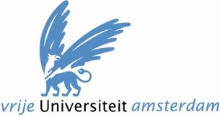

Faculteit der Exacte Wetenschappen
Vrije Universiteit Amsterdam
The Netherlands
Preface
Time flies like an arrow.
Two year ago, I opted for Multimedia and Culture at Vrije Universiteit Amsterdam because I had a wide interest in the research connecting art and technology. Doing practical projects, cooperating with museums, interview with artists, presenting artworks, publishing papers… all things that happened in these two years bring me an original and meaningful experience far beyond my expectations.
The project of digital dossiers started as a follow up of the master course ‘Multimedia Casus’ in spring 2005, in collaboration with the Netherlands Institute for Cultural Heritage (ICN) and the Media Art Institute (Montevideo). My master project aimed for further design and implementation of the abramovic dossier to present a collection of artworks of the Serbian-Dutch performance artist Marina Abramovic together with the artwork related information for preservation and re-installations.
What is my contribution to the project?
- Overall visual design
  - Web design of the frontpage website
  - Interface design of the Online Content Management Tool (OCMT)
- Technical development and realization of the digital dossier
  - Prototype of concept graph (teamwork)
  - 3D introduction of the digital dossier
  - Online Content management Tool (OCMT) (teamwork)
- Research issues
  - Navigation and presentation of multiple collections of artworks (with Chris van Riel)
  - Guided tour(s) with regard to information exploration and guidance (with Chris van Riel)
  - Explore a content-based approach based on personalization
Furthermore, I also have 4 publications during the master project of the digital dossier together with Chris van Riel and Anton Eliëns.
- Wang Y., Eliëns A., van Riel C., Content-oriented presentation and personalized interface of cultural heritage in digital dossiers, accepted for: InSciT2006, October, 2006, Spain
- van Riel C., Wang Y., Eliëns A., Concept map as visual interface in 3D Digital Dossiers: implementation and realization of the Music Dossier, accepted for: CMC2006, Costa Rica, September, 2006
- Eliëns A, van Riel C., Wang Y., Navigating media-rich information spaces using concept graphs - the abramovic dossier, accepted for: InSciT2006, October, 2006, Spain
- van Riel C., Eliëns A., Wang Y., Exploration and guidance in media-rich information spaces: the implementation and realization of guided tours in digital dossiers, accepted for: International Conference on Multidisciplinary Information Sciences and Technologies (InSciT2006), October, 2006, Mérida, Spain
Here I would like to express my gratitude to my partner Chris van Riel and my supervisor Dr. A. Eliëns. The close collaboration between us three was intensive, at some times accompanied by frustration and arguments. However, it was very pleasant and fruitful, which had a great impact on me. Also, I would like to thank Tatja Scholte from ICN for providing us artwork materials and valuable information in contemporary art and cultural heritage.
Much support has also come from my parents, Cuijuan and Hongsheng. It is their unconditional love and understanding that keep me going on. Also, thanks to Niba, an old friend in Shanghai who helps me with his great knowledge of Chinese literature and poetry.
I appreciate everyone who made contributions to the thesis, to the research behind thesis, and to the life behind research.

Yiwen Wang

July, 2006
Amsterdam
Abstract
Digitization of cultural heritage becomes an important requisite for remote co-operation, education and tourism between art institutes, museums and the general public since the 90’s. Based on the demand to access the scattered collections from the Netherlands Institute for Cultural Heritage and Media Art Institute, we designed and implemented a digital dossier in a 3D environment to present media-rich collections together with the artwork related information for preservation and re-installations. In the thesis, we indicate the digitalization of cultural heritage in the international context and describe the digital abramovic dossier by providing user scenarios. Focusing on the issues of navigation, presentation and personalization, we discuss the alternative ways to present rich media information of artworks in all its diversity. After analyzing the difference between presenting contemporary and traditional artworks, we explore a content-oriented approach combined with user personalization, which aims to re-present the original context of multiple artworks in a proper way suiting different users.

Keywords:
Digital dossier, abramovic, artwork, cultural heritage, presentation, navigation, concept graph, personalization, 3D, content-oriented.
Content

1 Introduction 8
1.1 Background 8
1.2 History and context of the digital dossiers 8
1.3 The abramovic dossier 9
1.4 Research issues and questions 10
1.5 Thesis structure 11

2 Digitization of cultural heritage in context 12
2.1 Current situation 12
2.2 Cultural heritage projects in the Netherlands and Europe 13
2.2.1 INCCA 14
2.2.2 CATCH 15
2.2.3 Other related projects 15

3 The abramovic dossier 16
3.1 Project objective and requirements 16
3.2 Design and implementation 17
3.2.1 Navigation in the concept graph 17
3.2.2 Presentation environment 19
3.3 Combination of navigation and presentation 20
3.4 User scenarios in the abramovic dossier 20
3.5 User evaluation 22

4 Content management 23
4.1 Metadata 23
4.2 Environment and VRML 23
4.3 XML and the Dublin Core 24

5 Extensions 26
5.1 Frontpage 26
5.2 Flat version of the abramovic dossier 27
5.3 Online Content Management Tool (OCMT) 27

6 Presentation issues 29
6.1 Information gadget with 3 windows 29
6.2 Different presentation facilities for 2D and 3D content 29
6.3 Alternative visualization paradigms 32

7 Guided tours 35
7.1 Fundamental concepts 35
7.2 Spatial guided tour 36
7.3 Conceptual guided tour 37
7.4 Object focused guided tour 37

8 Best practices in guided exploration – two case studies 40
8.1 Tours at Musée du Louvre – users and interests 40
8.1.1 Normal tours 40
8.1.2 Special tour of the ‘Da Vinci Code’ 41
8.2 Tate Modern Art Museum – new classification(s) 41
8.3 Reflection - a content-oriented approach 43

9 Reproduction of art in the digital age 44

10 Conclusion 46

References……………………………………………..……………………………………. 48

Appendix - to my dear Chinese readers……………………..…...………………………… 50

Chapter 1
Introduction
A digital journey 玉华寒，冰壶冻[1]
This chapter will give an overview of the thesis describing my master project, consisting of the project background, summary of the digital dossiers and research issues. The structure of the thesis is explained in the final section of this chapter.
1.1 Background
For quite some time, researchers are facing the problem of cultural heritage that a large amount of artwork collections are separated in different institutes. By time and space, it restricts the presentation of the diverse cultural information in a more widely immersive way for education, research and tourism. As a consequence, many applications/projects are created to build a growing and evolving multidisciplinary and integrative network between archives, libraries, museums and other research institutions in Europe.
Based on the demand to access the scattered collections from ICN and Montevideo, we made the research of digitization solutions and implemented a digital dossier in 3D space to present a large collection of artworks, together with the art related information for the preservation and re-installation. It is a multidisciplinary cooperation between the Netherlands cultural heritage institutes and multimedia research students group of Vrije Universiteit Amsterdam in the context of international projects (INCCA and European Culture 2000 project).
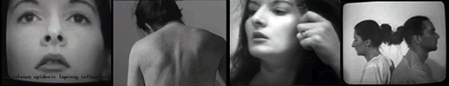
Figure 1. artworks from Marina Abramovic
1.2 History and context of the digital dossiers
We chose for the phrase digital dossier, and not for archive or library, to stress that our focus lies on a specific aspect on presentation. As a new phrase, the digital dossier was used as the key title of projects in Multimedia Casus since 2003. It has experienced three main stages so far:
- Casus 2004 spring
Dossier Boezem – to present artworks for artist Marinus Boezem
- Casus 2004 autumn
the abramovic dossier – to present artworks from performance artist Marina Abramovic
  - the music dossier – as a small practice, collect music data to compose a music dossier based on the structure of the abramovic dossier (fall 2005)
- Casus 2005 fall
Dossier Shaw to present artworks from performance artist Jeffery Shaw
As a student, I participated in the Casus 2004 autumn design and implemented the abramovic dossier, together with the other students. In the Casus 2005, I acted as student assistant to supervise students by giving suggestions and reviewing works in a leading role. Based on the previous work of the abramovic dossier, usability issues (e.g. adding filtering function and guided tour) were addressed. Furthermore, students realized the incorporation of 3D models of artworks, in this case for Shaw’s installation ‘Revolution’ and explored the personalized 3D environment.
All in all, my main contribution to the digital dossiers is in the realization of the abramovic dossier in Casus 2004 autumn and related research concerning the abramovic dossier and the Dossier Shaw (Casus 2005 fall).
1.3 The abramovic dossier
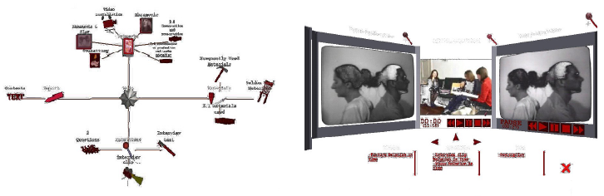
Figure 2. navigation in the abramovic dossier Figure 3. presentation in the abramovic dossier
The abramovic dossier presents artworks from Marina Abramovic, a Serbian-Dutch performance artist. It provides support for the following features:
- Navigation in concept graph
- Presentation with 3 information windows
- Personalizationa and guided tour(s)
For navigation, a concept graph is used to present the interrelated multimedia nodes in a structured hierarchy. This structure is dynamic depending on selected nodes and gives a visualized overview of the complex relationships, which include non-taxonomic relations, among the nodes.
We allow for the presentation of the media-rich content of collections in all its diversity. A content gadget consisting of three windows was designed to facilitate the presentation of multiple media content (text, pictures and video) simultaneously. Also, the 3D environment demonstrates the interactive presentation and exploration of the artwork objects. By manipulating the position/angle of view and objects, users can get insight in objects and how they are related together.
For personalization, we aim to provide an attractive and interactive interface/environment in a form that is appropriate for the actual users. The interface is adaptive to different users by changing the interface content like the environment attributes, models/objects and user’s viewpoint in 3D space.
Navigating such media-rich information spaces, where information structures can be complex, may result in disorientation and de-motivation. The need of suitable approaches able to support the exploration of such media-rich archives has motivated the development of several types of guided tours. It aims to support information retrieval, like locating objects of interest in a logical sequential order, and analysis, like learning how to interact with real-life objects or detecting relationship structures, in a dense information environment.
With the first prototype of the abramovic dossier, we did a user performance test in a qualitative way at ICN and Montevideo. It gave a positive and promising result as a new way to present information in an immersive fashion but also revealed some problems with regard to usability and personalization.
Finally, we extended the dossier with some additional features:
- Frontpage website
to present the abramovic dossier on the web
- Online Content Management Tool (OCMT)
to predefine data structures based on a more well-defined ontology
- Flat version of the abramovic dossier
web-based 2D dossier using DHTML, to avoid the need to install a plugin
1.4 Research issues and questions
As a demand-based project, the digital dossiers and related works have to meet the requirements of its stakeholders, the experts (curators) from museums as well as the potential non-expert users. For this we need to address the following issues:
- How to connect the scattered information of collections?
  - In what way to structure the information?
  - How to present this structure?
  - What is the relationship between the structure and the content of information?
- How to present the content of media rich information?
  - In what type of environment to present the information?
  - How to keep the authenticity and identity of the original information?
- How to realize a personal exploration in the active digital dossier?
  - How to facilitate personalized guidance in navigation?
  - How to make a personalized interface without confusion?
1.5 Thesis structure
The structure of this thesis is as follows.
An overview of the digital dossiers project is given in chapter 1, including background, summary of digital dossiers and related research issues. In chapter 2, we discuss the digitalization of cultural heritage in the international context. Then, we describe the abramovic dossier in somewhat more details, followed by a discussion of the content management issues, user evaluation and extensions in chapter 3. Based on a comparison of digital dossiers in two generations, in chapter 4 and 5, we discuss presentation issues and personalized guided tours, in chapters 6 and 7. We then look at two case studies of user guidance, based on the best practices of two leading museums, the Louvre (Paris) and the Tate (London), after which we propose, as a future research direction, a content-oriented approach to the personalization of guidance., Finally, following a brief reflection on the reproduction of art in the digital age, in chapter 9, we will, draw our conclusions.

Chapter 2
Digitization of cultural heritage in context
Art is international.[2] 云间玉兔
In the digital age of art reproduction, any information can be represented and stored as a string of bits, also referred to as digital convergence.[3] Therefore, the significant differences existing between objects, printed material, and even buildings or landscapes in the material world blurs in the digital environment. Digitization became a pre-requisite for closer co-operation between museums, archives and libraries, which are increasingly being treated collectively as memory institutions thus highlighting their common functions and roles.
However, due to high variations in interpretation of the content of digitization studies there are multiple approaches with different scope and context. Most often digitization becomes a part of diverse “umbrella” disciplines that employ various titles, such as digital librarianship, digital libraries, cultural heritage informatics and even broader ones as cultural or social informatics.
In this chapter, we discuss the international context of digitization of cultural heritage. After the general problem statement, some well-known digital projects of cultural heritage in Europe are given.
2.1 Current situation
Digital access to cultural heritage for the general public as well as research, education and tourism has become an important issue since the 90’s. At the G7 conference of the Information Society in 1995, a series of pilot projects were approved to show the potential offered by the Information Technologies. The Pilot Project N° 5 named “Multimedia Access to World Cultural Heritage” was implemented and had its first demonstration at ISAD conference in 1996. For the first time, digitisation of cultural heritage as an important issue in information society was recognized and considered.
Since then, many applications (e.g. ‘digital library/museum’, ‘e-culture’) are created based on the common interest of cultural heritage by using the current technology in Europe. ECHO (European Cultural Heritage Online), as the first major project funded by the EU Commission was aimed to create a growing and evolving multidisciplinary and integrative network of research institutes, archives, libraries, museums and other institutions. In the Netherlands, the research program CATCH (Continuous Access to Cultural Heritage) aims at providing new solutions for accessing digital collections, focusing on the support of collection managers of cultural heritage institutions. [4]
Following the trend, the Intelligent Multimedia group of Vrije Universiteit Amsterdam started cooperation with Netherlands Institute for Cultural Heritage (ICN) and Media Art Institute (Montevideo) in 2004. ICN is a leading, independent knowledge institute for the preservation and management of moveable cultural heritage. Also, it is coordinator of International Network for the Conservation of Contemporary Art (INCCA). With ICN, the Vrije Universiteit started the Multimedia Casus in 2002.
Participants in the Multimedia Casus group 2004, had a related technical background, with students from artificial intelligence, information science, industrial design and grid computing. As a demand-pull project, our task is to ‘Design and build a virtual environment (3D), that serves as a digital dossier to present rich-media collections of artworks. for the contemporary Serbian-Dutch performer artist Marina Abramovic’. The target users could be either expert users like curators, researcher or non-experts like the general public.
Despite all the digital collections of contemporary art, we encountered many problems which obstructed our progress, problems which are also reported by other cultural heritage projects. [4]
In summary, we may distinguish 5 points as below:
- Big volume: The first digital dossier only presents Abramovic one artist’s works but it already contains a large amount of collections, including 40 texts, 10 reports, 8 interview clips, 82 pictures, 23 materials, etc. If more artists’ collections added, the total size will be enormous.
- Wide diversity: The collections of Abramovic’s artwork range from 2D pictures to performance videos, from real objects to paintings, from instruction texts to record audios. Besides, when it is presented in 3D environment, some 3D models are created according to the special installation artworks in real life.
- Multiple relationships: Most collections are highly inter-related. For instance, from a particular artwork, it links to its material. From this material, it links to other artworks which also use it.
- Context enrichment: Presenting the final product does not satisfy expert users who want to explore the traditional context. How to re-present the artwork’s unique existence at the place where it happens to be?
- Multiple users: The user type of the digital reproduction ranges from museum curators to kids, from professional researchers to people who like art. How to meet different requirements from different user types?
2.2 Cultural heritage projects in the Netherlands and Europe
Collaboration between institutions brings multiple benefits because it destroys artificial barriers posed by different formats and provides a holistic view of collections preserved in libraries, museums and archives. Therefore, on a practical level institutions explore possible ways of collaboration and on the theoretical level convergence or, at least, closer interaction and interchange of knowledge is considered as a future of the disciplines. [5]
Here we introduce some cultural heritage projects, mainly from the Netherlands and also some from other countries in Europe.
    - INCCA
International Network for the Conservation of Contemporary Art (INCCA) is a network of professionals connected to the conservation of modern and contemporary art and was established to meet the need for an international platform for knowledge and information exchange. Conservators, curators, scientists, registrars, archivists, art historians and researchers are among its members. Since its inception in 1999, the network has grown from 23 to over 100 members (including independents) from 50 organizations in 14 countries.
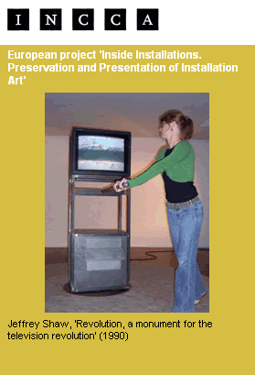
Figure 4. ‘Revolution’ from Jeffrey Shaw

Based on INCCA, the European project - Inside Installations, Preservation and Presentation of Installation Art was created in 2004. It is a three years project supported by the European Commission’s Culture 2000 program. It is also coordinated by the Netherlands Institute for Cultural Heritage (ICN) and co-organized by five other European organizations: TATE, England; Restaurierungzentrum Düsseldorf, Germany; Museo Nacional Centro de Arte Reina Sofia, Spain; Stedelijk Museum voor Actuele Kunst, Belgium and the Foundation for the Conservation of Contemporary Art, The Netherlands. It is one of the initiatives of the International Network for the Conservation of Contemporary Art which exists since 2002 as a platform for exchange of knowledge and information.
The research is based on 30 case studies of installation works in the collections of participating museums. From the framework of case studies good practice and tools are developed under five main topics:
- Preservation Strategies
- Artists’ Participation
- Documentation & Archiving strategies
- Theory and Semantics
- Knowledge Management and Information Exchange
    - CATCH
CATCH is a Dutch national research program: Continuous Access To Cultural Heritage. It is a joint initiative of the boards of the NWO Divisions of Physical Sciences and Humanities, the Netherlands Institute for Image and Sound, the Royal Library, the National Archive, the National Museum of Natural History (Naturalis), the National Service for Archaeological Heritage and the Rijksmuseum Amsterdam.
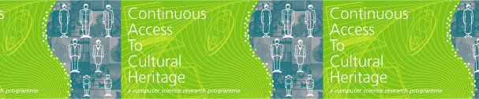
Figure 5. CATCH project
CATCH aims to develop methods and technologies for document-collection and archive managers who want to enhance the accessibility of the Dutch cultural heritage on digital platforms such as public web sites. It focuses on the support of collection managers of cultural heritage institutions with three themes: [4]
- Semantic operability through metadata
- Knowledge enrichment through automated analyses
- Personalization through presentation.
    - Other related projects
- Digital Heritage and Cultural Content (DigiCULT) [5]
to provide opportunities to optimise the development, access to, and preservation of Europe's rich cultural and scientific heritage.
- European Cultural Heritage Online (ECHO) [7]
to create an Agora, a community of producers and users of culturally relevant information, who are willing to freely exchange this in order to build a joint portal and a common infrastructure.
- Cultural Heritage Interchange Ontology Standardization (CHIOS) [8]
to facilitate interchange and interoperability of cultural heritage information between museums, libraries and archives.
- Contemporary Culture Virtual Archive in XML (COVAX) [9]
to combine document descriptions and digitized surrogates from libraries, archives and museum, to build a global system for search and retrieval.
Chapter 3
The abramovic dossier
Everything is interwinkled. 水面苍龙
As a member of the Multimedia Casus autumn 2004 group, we started this student’s project collaborated with the Netherlands Institute for Cultural Heritage (ICN) and the Netherlands Media Art Institute (Montevideo) in November 2004. Our task was to present artworks from a particular artist, Marina Abramovic, a Serbian-Dutch artist who became well-known in the 70’s with her numerous performances, installations, videos and other works.

The abramovic dossier supports:
- navigation with concept graph
- presentation in 3 information windows
- personalization and guided tour(s)
3.1 Project objective and requirements
Objective:
- To design and build a 3D virtual environment that serves as a digital dossier, for the contemporary Serbian Dutch performer artist Marina Abramovic.
Why in 3D?
- To find a way to present and structure existing information about preservation, conservation, reconstruction, presentation and materials of the artworks of Marina Abramovic in a more intuitive and useful way.
- Presenting 2D information in 3D can evoke new insights by making use of the 3D space. Structures and relations between objects can be presented in a glance of the eye.
- By making the information better accessible with 3D virtual environment, we hope to add extra value to the information that already exists and contribute to the work of the conservators of these artworks
Requirements:
- The digital dossier must be ‘intertwinkled’. This means that all information objects in the virtual environment that are already related in the existing information, must be also be related in the virtual environment by hyper linking. For example: Interview clips about a particular artwork must be linked to images of that artwork.
- The digital dossier must be suitable for professional conservators and conservator students.
3.2 Design and implementation
Compared with the common concept of virtual museum or virtual library, we decided to explore alternative ways to present and navigate artwork collections in 3D. The phrase ‘digital dossier’ was chosen to focus on intuitive presentation. To clarify the definition of digital dossier, we first looked “dossier” up in dictionaries:
Webster New World Dictionary
- dossier (dos-si-er) [ Fr < dos (back); so named because labeled on the back ] a collection of documents concerning a particular person or matter
- archive -- 1) a place where public records are kept ... 2) the records, material itself ...
Random House Unabridged Dictionary
- a collection or file of documents on the same subject, esp. a complete file containing detailed information about a person or topic.
Here we give our definition of digital dossier:
- A digital dossier represents the information that is available for a particular work of art, or a collection of works, of a particular artist, in an easily accessible way.
    - Navigation in the concept graph
As a user interface for navigating the digital dossier, we created a concept graph that represents complex information structures. The concept graph allows the user to detect relations and search for information. Unlike the 3D cone tree, where a complete hierarchical structure is presented, only a subset of the related information is shown - three levels deep.
The concept graph is implemented as a star-structured-hierarchy diagram representing related information objects. By star-structured we mean that relations between information objects are visualized by lines, getting a structure consisting of parent-child relationships, showing a centered information object surrounded by related information objects.
The actual structure, originated by the parent-child relationships, is dynamically generated when selecting an information object. The selected object will be translated to the center of the screen, involving movement in the X and Y direction. It then becomes a parent node showing its children around it. The structure presented is dynamic and actually determined by the user’s choice. To compensate for the lack of an instant overview, where all information is shown at once, the user can also use keyword search instead of navigation.
In summary, there are two ways of finding information in the digital dossier:
- Concept graph navigation - Through selecting an information object it becomes the center node showing its relations to other nodes. (see figure 6)
- Keyword search - enables the user to locate information based on textual input. (see figure 7)
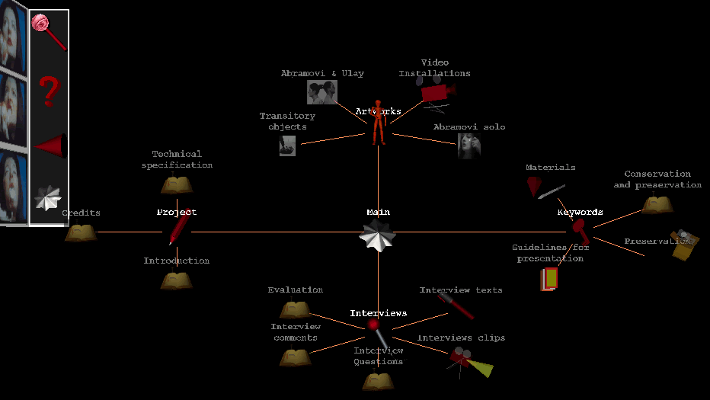
Concept graph
keywords search

help

back

main node
Tool bar
Main node
Figure 6. navigation in the concept graph

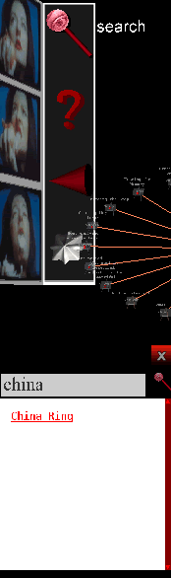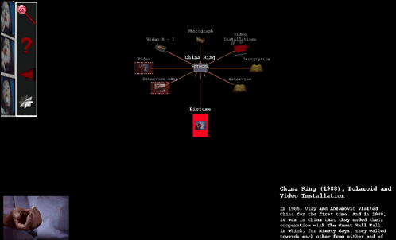
Figure 7. keywords search in the concept graph

Information objects shown in the concept graph are represented by 3D icons. These 3D icons visualize a certain type of information. The icons tell the user what information s/he can expect when clicking on it. We distinguish between two information types:
- Conceptual information type – 3D models that represents categories.
- Content information type – 3D models that represents certain types of content.

The content information type itself consists of different media types. These are:
- Text content type – 3D models that represents textual content.
- Picture content type – 3D models that represents static visual content.
- Video content type – 3D models that represents audiovisual information.
    - Presentation environment
Presentation of media content is supported by different visualization facilities. Presentation is an essential part of the digital dossier, distinct from navigation. The presentation facilities are deployed when media content is selected for view. The digital dossier contains different presentation facilities for 2D and 3D content.
For 2D media content a visualization facility is needed that is able to present video, images or textual information. This facility is implemented as a content gadget with three windows. In each of the three windows the user can view 2D media content. These windows are positioned in such a way that the user can inspect the information simultaneously without much visual distortion. Below the three windows a list of all content related to the selected information object is displayed. The available content is listed in categorized lists for each content type. The user can control on which of the three windows content is displayed. By using drag-and-drop. the user can view content on a window of choice. It gives the user some freedom for customization instead of being bounded to a fixed display. (See figure 8)
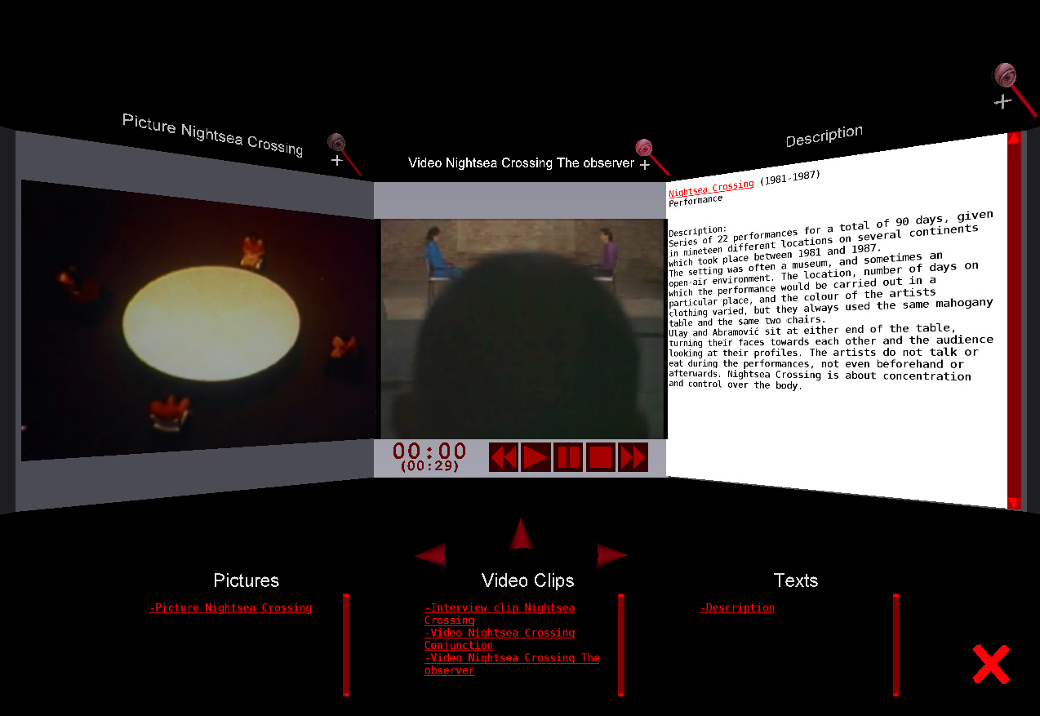
Information gadget -- 3 windows
Information items
Window selection
Zoom in
Quit and go back to concept graph
Figure 8. information gadget in the presentation enviroment
In addition, the user can also focus on specific information in a particular window with a zoom (in/out) option, to avoid distraction from the other windows. For instance, the video information is focused on one window with a selection of low or high resolutions in figure 9 by using the zoom-in function. (see figure 9)

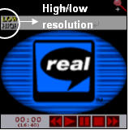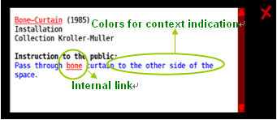
Figure 9. zoom in video information Figure 10. colors and links in text information

3.3 Combination of navigation and presentation
In the abramovic dossier, navigation and presentation is combined in an immersive way. Immersive means here that it is easy to switch between them without popping up a new window or starting a separate application.
Navigation can also take place, directly from the information that is presented in the presentation gadget. For instance, some text information about a particular artwork is shown on the text window of information gadget (figure 10). In the textual description, different colors and links are used to describe the indication. If the user clicks on the link ‘bone’ in red, it immediately goes to the concept graph in the navigation concept graph where ‘cow bones’ locates as the center node surrounded by related information nodes. (see figure 11)
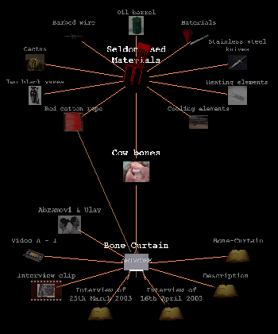
Figure 11. Cow bones in the concept graph
3.4 User scenarios in the abramovic dossier
Suppose, you are a user who wants to see Abramovic’s artwork ‘China Ring’. You might be an expert who knows a lot about ‘China Ring’ or a novice who knows little about it. Below, we give a user scenario in the digital dossier, illustrating how to find the information about artwork ‘China Ring’.
First, imagine that you are an expert who knows that ‘China Ring’ belongs to installation category. You will experience the following 6 steps to find the information. (see figure 12)
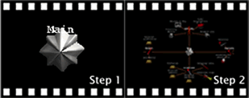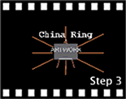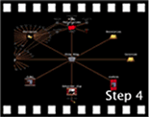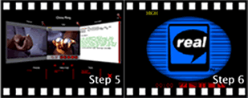
Figure 12. an expert user scenario of ‘China ring’
- Step 1: Start main node in the concept graph
- Step 2: Surfing in the concept graph by clicking on the star main node. The dynamic structure spreads and children objects appear surrounding the center node.
- Step 3: From main node, go to ‘artwork → installation’, then find ‘China ring’ via navigation in the concept graph. Alternatively, using the keyword search function of the tool bar, ‘China Ring’ can be easily found.
- Step 4: ‘China ring’ node move to the center position by clicking, surrounded by all its children nodes, which present information of ‘China ring’ in text, picture and video format.
- Step 5: The content presentation environment appears by clicking on the center ‘China Ring’ node. It opens with 3 windows to present different information which are listed below the windows. Here, the picture of ‘China Ring’ is presented in the left window, video in the middle window and text description in the right window.
- Step 6: if desired, the user can focus on any window by using a zoom in/out function.
Second, imagine, you are a novice who does not know where to find ‘China Ring’ or probably you do not want to navigate in the confusing concept graph. So the best way to find ‘China Ring’ is to use the tool bar on the left-up corner. Compared with the expert user scenario, the only different steps are step 2 and 3, the rest are the same. (see figure 13)
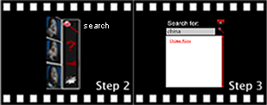
Figure 13. a novice user scenario of ‘China Ring’
- Step 2: Use the search function in the tool bar
- Step 3: Input ‘China’ as a keyword to search, the artwork ‘China Ring’ is immediately shown in the result area. By clicking on it, ‘China Ring’ is easily found as the center node in the concept graph.
When the presentation of media content is finished, clicking on the close button will result in going back to the concept graph. Alternatively, the ‘home’ function of the tool bar, may be used to return directly to where we started, the original shining star.
3.5 User evaluation
As an explorative development project, we did not do any user study or user requirements research before the implementation. However, afterwards, we did a simple user evaluation with potential end-users, the experts from ICN and Montevideo. The expert users were given a task to find information about a particular artwork in limited time using the dossier and then to explain the result.
The evaluation is a variation of a think-aloud evaluation and has the following advantages:
- It's easy to conduct, and involves no extra costs.
- It delivers test results in a relatively short time.
- It encourages the user to criticize the application and the style of interaction.
- The actual evaluation sessions of the digital dossier were recorded on video.
The evaluation was designed to assess domain related tasks where the user uses all functionality related available for navigation and presentation. It focused on the following aspects:
- Navigational actions
- Interpretation of navigational results
- Interpretation and detection of relations between information
- Presentation of content
- Functionality of presentation gadget
The test results give a first indication of the usability of the digital dossier:
- Positive results:
  - The concept graph makes it easy to detect relations between information
  - Using a concept graph for navigation appeared to be intuitive for all users
  - The close relation between the concept graph and presented media reduces dis-orientation.
- Negative results:
  - The meaning of 3D icons was not well understood
  - The users expressed the wish to customize the visual appearance of the concept graph and the icons used.
In general, we conclude that the concept graph supports both intuitive navigation and relationship detection. However improvement of the visual appearance of the digital dossier is definitely possible and desired.
Chapter 4
Content management
Life is data. 酒一樽
Technology of conversion refers to the specific techniques, which are used to convert original materials to digital form (i.e. digitization) and the techniques of converting digital materials from one format to another. [10] The primary concern in the digitization is to ensure a pre-defined reliability and fidelity of the new digital artifacts in comparison to the originals. The technical issue is to provide automated measures to ensure the integrity and reliability of the conversion, as the digitized quantities are typically large or very large.
In these chapter we will, as a background for the OCMT described in chapter 5, briefly discuss the issues of content management, in particular the notion of metadata, the actual data structures used in the VRML environment, and the transcoding of these data structures to an XML representation based on the Dublin Core.
4.1 Metadata
The term metadata has been used only in the past 15 years, and has become very common with the popularity of the World Wide Web. The definition of metadata that is most known may be paraphrased as "Metadata is data about data”.[10] It describes the attributes and contents of an original document or work, and can help to relieve potential data users from having to have full advance knowledge of a dataset's existence and characteristics.
In the field of cultural heritage, metadata standards have been developed for museum cataloguing. Similar data about digital "information objects" (web pages, digital images, etc.) is usually referred to as "metadata". However, the term "metadata" is also sometimes used to refer to data about non-digital objects such as physical objects in museum collections. Therefore, museum collections management records (whether paper-based or automated) would be considered by some to be "metadata" about the collection. [12]
4.2 Environment and VRML
The technology used to create the digital dossier is the Virtual Reality Modeling Language (VRML) with a Blaxxun plugin. We have chosen for VRML because it supports the project aim of creating a digital dossier in a virtual environment. Specific for VRML because it was the standard virtual reality modeling language set by the Organization for Standardization (ISO) at the time we started. During the project the ISO has set a new standard X3D for 3D communication.
It allows creating virtual worlds connected via the Internet and hyperlinked with the World Wide Web to expose the digital dossier to a broader audience. Since we adopted 3D technology, we could easily accommodate a 3D model for the application. The 3D environment demonstrates the interactive exploration of the installation of an artwork. By manipulating position and/or angle of objects, users can get insight into how the models could be interacted.
Using 3D technology VRML, the whole environment and related 3D models in the application can be accommodated. First, implement a plain exhibition space; second, incorporate the 3D models with an extra right-click function of pop-up the property setting windows. It aims to provide a 3D perspective of the application that allows the user to manipulate the position of the objects by a click-and-drag function. Furthermore, VRML does also support 3D sound properties, including spatial positioning and distance-based decay. The 3D environment demonstrates the interactive exploration of the objects in the space. By manipulating position and/or angle of view and objects, users can get insight into how the objects could work together to produce different sound.
Typical data structures for nodes in the concept graph use the VRML prototype declaration, which may be regarded as a collection of named attributed with typed values, with basic types ranging over integers, and a generic list type for each basic type.
In the actual implemtation of the digital dossier, we used the following record-like structures:
- Video -- to display video fragment, including interviews
- Picture -- to present pictures of the artwork
- Artwork -- contains all information connected to a work of art
- TextItem -- to present text, from the interview or any other source
- MaterialItem -- to present information about material(s) used
- GroupNode -- to combine nodes in the concpet graph
- Information -- acts as the outer container for all nodes
Such structures can be easily transcoded in any format that support structured collections of possibly multi-valued attributes, such as XML. For further details, see [13].
4.3 XML and the Dublin Core
The Dublin Core is a metadata element set, a standard for cross-domain information resource description. It includes all DCMI terms (that is, refinements, encoding schemes, and controlled vocabulary terms) intended to facilitate discovery of resources. [29] It is a general resource description formalism that allows or specifying resources in a variety of domains.
Dublin Core is the standard used in the INCCA initiative, to record meta-information about existing information sources. For INCCA the Dublin Core was chosen, not because it is the most suitable formalism, but because it may serve as least common denominator, and agreement on anything else simply seemed to be impossible.
The Dublin Core provides the following elements:
- title -- name given to the resource
- creator -- entity primarily responsible for making the content of the resource
- subject -- topic of the content of the resource
- description -- an account of the content of the resource
- publisher -- entity responsible for making the resource available
- contributor -- entity responsible for making contributions to the content of the resource
- date -- date of an event in the lifecycle of the resource
- type -- nature or genre of the content of the resource
- format -- physical or digital manifestation of the resource
- identifier -- unambiguous reference to the resource within a given context
- source -- reference to a resource from which the present resource is derived
- language -- language of the intellectual content of the resource
- relation -- reference to a related resource
- coverage -- extent or scope of the content of the resource
- rights -- information about rights held in and over the resource
As observed in [13]: “descriptions of items in the digital dossier should incorporate these elements, together with the attributes needed for the insertion of items in the concept graph and the presentation parameters, that are necessary for displaying the (media) material. Technically, the namespaces supported by RDF does allow for merging these different types of annotations. However, the challenge here is to derive the presentation attributes automatically, and to come up with a reasonable default for inserting these items in the concept graph”.
In the content management tool (OCMT), described in the next chapter, takes XML as its underlying representation, ans allows for the inclusion of additional presentation attributes for media-specific presentation.
Chapter 5
Extensions
Progress is optional. 琴三弄
Based on the prototype of the abramovic dossier which focuses on presentation and navigation, my partner Chris van Riel and I chose to focus further development and research on the following issues:
- Presentation on the web (Fontpage website)
- Online Content Management Tool (OCMT)
- A ‘flat’version, using standard web technology
5.1 Frontpage
To present all our works of the abramovic dossier in a well-organized and attractive way on the web, we decided to build a project website. (see figure 14) Also, it provides a channel for sharing knowledge and product of the abramovic dossier, open discussion with more people and future development or cooperation.
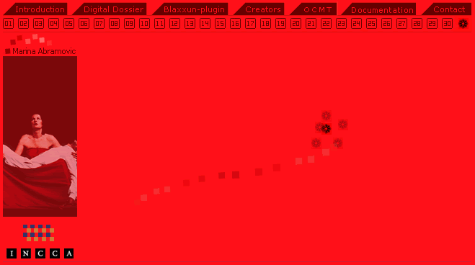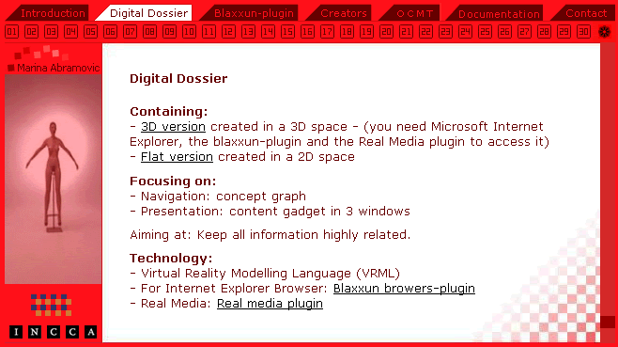
Figure 14. frontpage on the web
To make a beautiful frontpage, we had a small competition of the design within the students group. My design ‘red’ won the competition selected by the people from ICN. The inspiration came from Abramovic’s artworks ‘Thomas Lips’ (1975) and ‘Red Period’ (1998). (see figure 15 and 16)
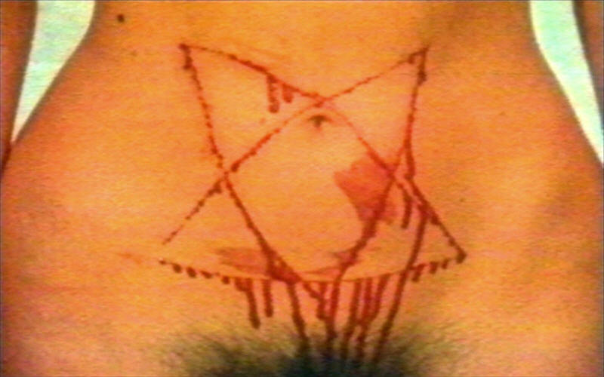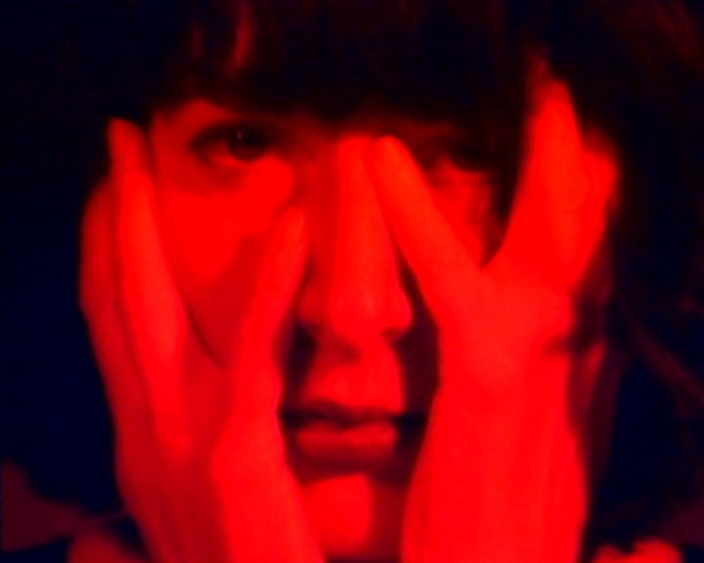
Figure 15. Thomas Lips Figure 16. Red period
In the performance 'Thomas Lips', Marina Abramovic undertakes a range of actions that push her physical limits to an extreme and finally result in the transgression of bodily boundaries by cutting a five-pointed star into her stomach with a razor blade. 'Red Period' shows a close up of Abramovic in red. With a seducing smile she gestures with her finger to invite the viewer closer.
Inspired from these 2 artworks, I felt that color red seems to refer to the symbolic transmitter of attraction. Therefore finally monochrome red was used as the main element for the frontpage website, together with black and white as minor colors. Although it might bring users visual feelings like dominance, it shows a strong identity about the artists herself and to transfer a power and energy.
5.2 Flat version of the abramovic dossier
Based on 3D abramovic dossier, we created the flat version in 2D space. The interface consists of 3 frames: structure frame in the left, content frame in the top right and relation frame in the bottom right. The structure frame gives the tree structure of all information nodes expanding from four categories (artworks, keywords, interview and projects) to leave nodes of detailed objects. When a specific leave node is clicked, its content will be shown in the content frame. It could be a picture, texts or a video depending on the content of object itself. Users could also use the search function in this frame to seek a particular object. Correspondingly, the relationship with other nodes is displayed within one level in the relation frame. (see figure 17)
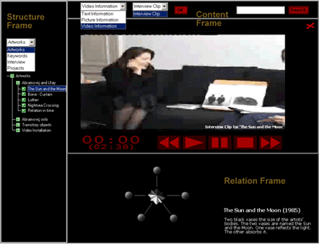
Figure 17. flat version of the abramovic dossier
5.3 Online Content Management Tool (OCMT)
As an extension to the digital dossier we created a web-based tool which generates XML (Extendible Markup Language) structured data output from unstructured information input. The tool has initially been created for non-expert VRML users who want to create a 3D digital dossier in a relatively quick and easy way, without programming or adjusting existing code. By using the tool, the user can fill in information about information objects and indicate relations between objects. User input will be used to generate the digital dossier.
Below we give a workflow of how the OCMT works. It starts with users (intern and extern) who want to make their own digital dossier. By using the online content management tool, they can deliver the source data which will be processed and output as DC/XML format data into the database through OCMT. Then these DC/XML data will be imported into the digital dossier in both 3D and flat version. (see figure 18)
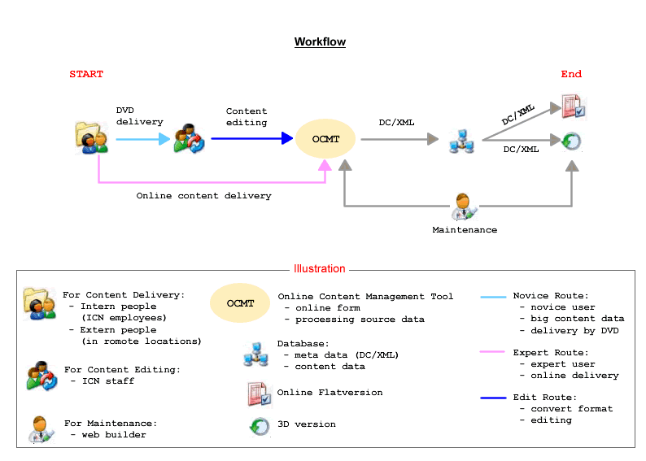
Figure 18. workflow of OCMT
The interface design of OCMT continued the frontpage website style using red, black and white color but in more clear way. The timeline shows the total steps as well as the current status by filling in as solid donuts automatically. (see figure 19)
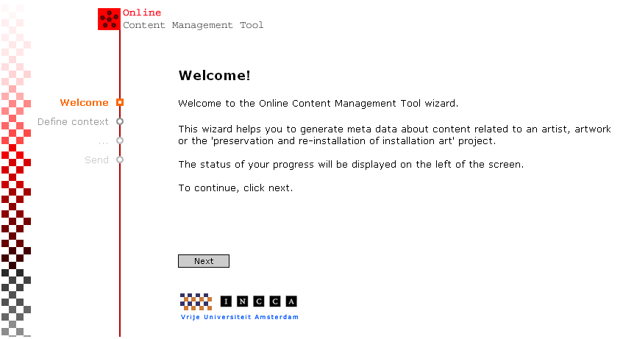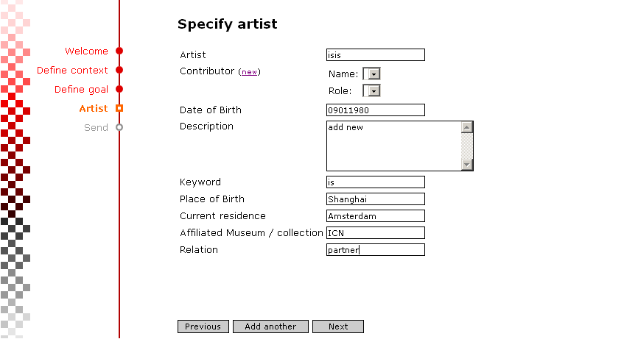
Figure 19. interface of OCMT
Chapter 6
Presentation issues
Art must be Beautiful, artist must be Beautiful. 唤起凌波仙人梦

As a practical project, the abramovic dossier also brings interesting research issues about presentation and guided tours. This chapter will first discuss the presentation issues. It includes a discussion of:
- the presentation gadget with 3 windows
- different presentation facilities for 2D and 3D content
- alternative visualization paradigms
The next chapter, chapter 7, will then give an overview of guided tours.
6.1 Information gadget with 3 windows
The information gadget with 3 windows was designed to present multiple information in an optimal way. In figure 20, image, video and text information are displayed at different windows at same time. Other information listed below windows could be selected or click-drag to the display on a particular window. It provides users maximal information in a simultaneous way. (see figure 20)
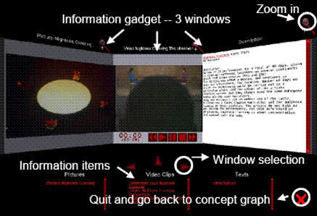
Figure 20. information gadget
6.2 Different presentation facilities for 2D and 3D content
The abramovic dossier presents not only 2D content in the information gadget but also 3D content by creating and incorporating 3D models adopting 3D technology.
For instance, we implemented a plain exhibition room, providing a 3D perspective of the installation ‘Terra degli dea madre’ that allows the user to manipulate the position of the objects by a click-and-drag function. The 3D environment demonstrates the interactive exploration of the installation of an artwork. By manipulating position and/or angle of objects, users can get insight into how the artwork could be exhibited. (see figure 21 and 22)
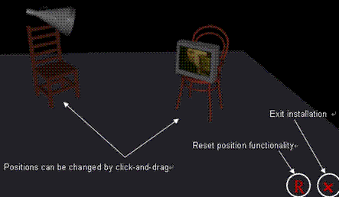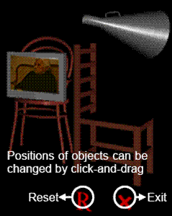
Figure 21. 3D installation of 'Terra degli dea madre' Figure 22. manipulate and move
Besides, the concept graph in navigation also provides an intuitive overview combining 2D and 3D models of the information nodes. For instance, ‘frequently used materials’ as the center node is surrounded by many related children nodes which are belongs to the category of ‘frequently used materials’ in the figure 23.
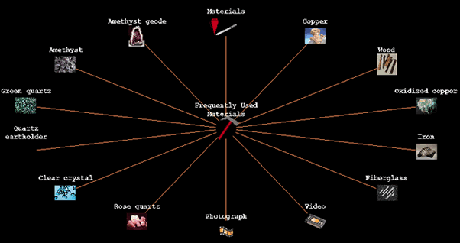
Figure 23. 2D and 3D models in concept graph
Here, let’s take a look at the combination of 3D models and 2D images built in the concept graph for navigation in figure 23. The 3D models like ‘Materials’ are used to indicate the concept nodes. It allows for rotation and zoom in to get a close and intuitive recognition by the user. (see figure 24)
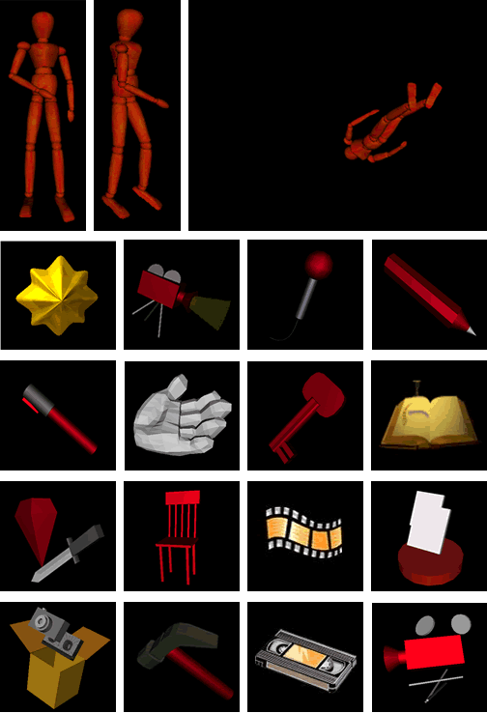 Figure 24. 3D models
The 2D images, see figure 25, were only used when 3D models seemed not appropriate, for example as a representation of the materials used in the artworks, such as crystals, stone, etcetera.
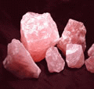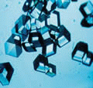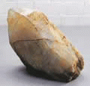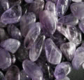
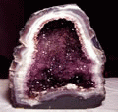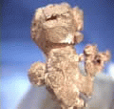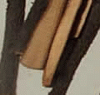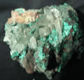
Figure 25. 2D images
However, as indicated in discussing the user evaluation, improvement of the visual appearance of the abramovic dossier is definitely possible and, apparently, desired. When demonstrating the application to the interested parties, that is ICN and Montevideo, a number of issues came along, that we will here summarize as a list of questions: [14]
- What icons/models should be used to identify the information nodes of the concept graph?
- What categories and relationships are most appropriate?
- How should the information be displayed, simultaneously or more focussed?
- How do we allow the user to choose between multiple information items?
- How do we avoid visually disturbing elements?
6.3 Alternative visualization paradigms
Many different visualization techniques for navigation hierarchical information structures have already been proposed. See for example [14] and [16]. These visualizations can be in 2D or 3D and are needed to interpret the intended hierarchy of a particular information collection. Such diagrams are aimed at reducing the cognitive load for the user. A well-known example of the 3D information visualization is the 3D cone tree. [16] Here, we list the following three visualization paradigms for comparison: [17]
- Cone tree visualizing hierarchy (see figure 26)
- Concept graph in 3D (see figure 27)
- Concept graph in 2D flash (see figure 28)
The concept graph in 2D flash was developed in the Multimedia Casus 2005, whereas the concept graph in 3D is the representation used in the abramovic dossier.
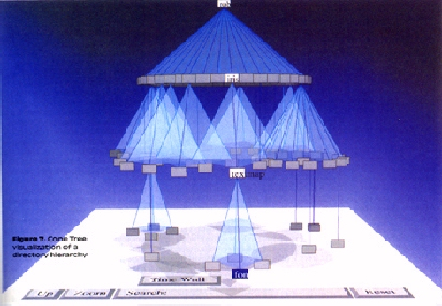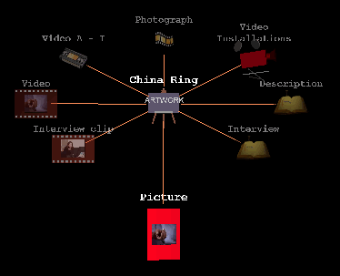
Figure 26. cone tree visualizing hierarchy Figure 27. concept graph in 3D
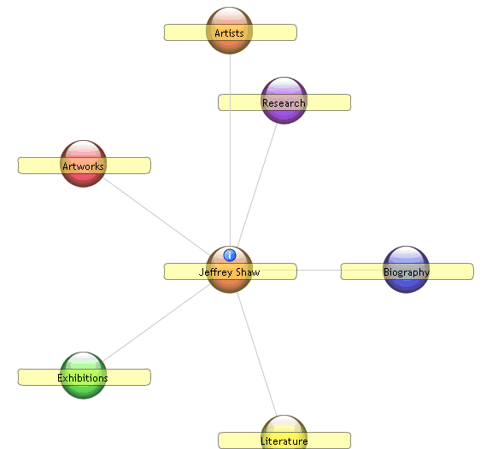
Figure 28. concept graph in 2D

- Cone trees in 3D
- 3D visualizations of cone trees make optimal use of screen space and provide the opportunity to visualize larger hierarchical structures.
- The cone tree presents all information at once. In case of a large amount of highly inter-related information structures this could lead to an information overflow.
- Concept graph in 3D
- The 3D concept graph presents information nodes in 3 levels of the hierarchy. By move and click, the 3-level structure changes dynamically due to the center node. It offers an overview of multiple relationships among different information nodes.
- The information nodes are created as 3D models mimicking real objects. A variety of realistic models give users a direct and clear expression related to the original objects.
- The complicated relationships between lines, models in the concept graph might confuse users, especially non-experts. More explanation or guided tours are needed.
- Some 3D models might mislead users. Some abstract 3D models are made based on artist’s definition/explanation and designer’s understanding. It is not precise enough to present without any misunderstanding or slight errors.
- Concept graph in 2D flash
- The 2D flash version of concept graph is very easy and friendly to users without too much confusion and difficulty.
- The information nodes in same style/template are not able to provide a vivid and rich image of the hidden information until click for the content presentation.
In summary, the advantages of the 3D concept graph used in the abramovic dossier is the direct intuition users may have of the type and content of a node, as well as the overview of three levels deep, providing a middle way between the all-level approach of the cone-tree and the two levels only of the flash 2D concept graph. An additional feature of the concept graph used in the abramovic dossier, is the automatic preview facility which activated when the user moves the mouse over the nodes of the displayed part of the graph.

Chapter 7
Guided tours
Welcome to Amsterdam 倚阑干满面天风
Personal exploration of media-rich environments in cultural heritage becomes more extensive and time consuming with respect to quantity and quality of the information present, and the awareness of information locations. In such cases, locations of the collection of information to be accessed may be too large to remember and or the location of information is not known, forcing the information to be retrieved based on its content, its attributes or its relationships to information whose location is known, [18] i.e. navigating through hyperspace. Navigation as such, due to the non-linear communication structure as found in media-rich environments, can cause some problems, like disorientation and quality loss in information retrieval. Also, the confrontation with high quality information, such as 3D representations that imposes greater information richness by six dimensional explorations, can affect the user in extensive and time consuming exploration i.e. the extent and awareness of 3D interaction possibilities.
7.1 Fundamental concepts
Directing the user's focus of attention by automation, in situations where navigation is non-linear may prevent the user from becoming lost or confused. Guided tours enable the designer to control which information is presented and in what order. Also exploration of information rich objects can be accommodated in this way. From this perspective, guided tours can be used to automate user navigation and interaction, and function as a narrative, story telling, facility, within an otherwise interactive application. Preliminary results indicate that the guided tours overcome problems of getting lost, and accommodate information retrieval and information processing. [18]
What is a guided tour?
A tour guide is a person or an application who leads tourists or other visitors around a town, museum, or other tourist site, or on a longer tour along a fairly well established tourist circuit. Such a tour is called a "guided tour".
During the three Casuses (2004 spring, 2004 autumn and 2005 fall), different guided tours have been developed and discussed. We distinguish between three types of guided tours:
- Spatial guided tour - automatic spatial guidance where objects are strongly related with the environment; allowing for manipulation of environmental parameters.
- Conceptual guided tour - automatic and focused presentation of conceptual information spaces and related media
- Object focused guided tour - automatic presentation of functional and/or technical aspects of real-world objects.
7.2 Spatial guided tour
A spatial guided tour was made by students group in Casus 2004 spring for the dossier Boezem, aiming to assist the user in locating information of interest and orientation in a spatial environment. [19] This tour has three characteristic features:
- It (the agent) acts as a museum guide
- It may gives guidance in answering questions about the artworks
- It provides a simulation of interaction with the artworks
The spatial guided tour uses a virtual atelier to represent two artworks of the expressive artist Marinus Boezem, by a 3D representation of which one is interactive and the other animated and related media. The aim of these representations is to inform the interested public about its use and presentation in an actual exhibition. Related 2D media content is accessed by real-life metaphors, like a file cabinet for text and a video projector for video. (see figure 29)
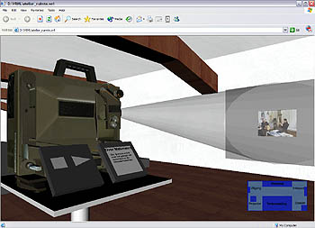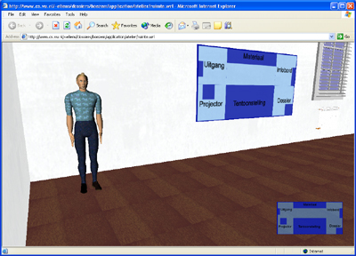
Figure 29. video projector showing audiovisual media Figure 30. virtual agent acting as museum guide
The navigational metaphor in the spatial guided tour is not abstract but realistic. Dealing with spatial environments as such requires to deal with spatial movement (limitations input devices and possible motion sickness) and orientation (being lost by lack of overview). Given this, the Boezem dossier uses an animated character (i.e. agent) that acts as a real-life museum guide (e.g. guiding, answering questions). (see figure 30)
This guided tour operates by changing the user’s viewpoint according to the position and transitions made by the virtual guide. To give the user more control over the environment a map of the virtual atelier can be used to jump to another place in the atelier.
Currently, this guided tour suffers from several limitations.
- it is desired that the agent must be interactively responding on user focus of interest and/or attention as opposed to predefined actions.
- with regard to interactive artwork installations, such guided tours could be extended with simulating interaction on artwork installations for the public, giving exhibitors insight in the use of the artwork and its environment, and based on this experiment with virtual environment parameters.
7.3 Conceptual guided tour
The conceptual guided tour is made by students group in Casus 2004 aumtumn for the abramovic dossier. The guided tour builds on the concept graph as navigation paradigm to represent conceptual knowledge ,see figure 31, and addresses the following issues:
- It provides a solution to deal with the complexity of the conceptual structure
- It may simulate actual navigateion, since it is based on mimicking interaction
- It is meant to help users locate information of interest, by telling a ‘story’.
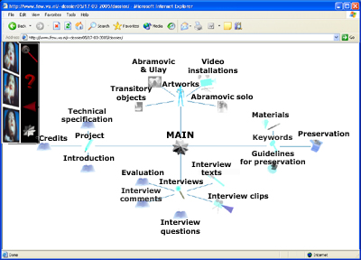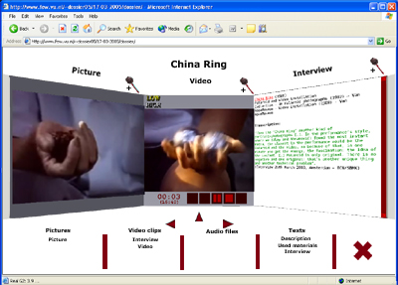
Figure 31. information structures in concept graph Figure 32. Content gadget with 3 windows
In the original dossier, by browsing the conceptual nodes, which causes the concept graph to change accordingly by a smooth transition, the user is able to detect relations between nodes and their related media content. When media content is selected for view, a 3D content gadget appears by which the user can select, view and focus on media, see figure 32. 3D representations of artworks can also be accessed in the conceptual space and are viewed in a 3D environment.
Due to the amount of relational data and complexity of the conceptual structure, a conceptual guided tour was developed that assists the user in information retrieval by directing focus of attention. This guidance - automating user interaction by a time-based sequence of events that activates navigational functions - uses the concept graph as a starting point to act as a narrative story facility to present information of interest. Media information is presented by activation of media related nodes visualized by the concept graph which changes by navigation. This allows the user to explore conceptual relations and related media or 3D representations by automation in a pre-defined conceptual context more effectively (presenting all relevant information in a narrative order given its conceptual context) and efficiently (avoiding time consuming manual navigation finding objects of interest) without getting lost or confused.
A remaining issue is to instantly respond to user exploration interactively., thus interrupting, possibly temporarily. How to provide a smooth continuation is an issue for future research.
7.4 Object focused guided tour
A collection of object focused guided tours was developed by the students group from the Casus 2005 fall for the dossier Jeffery Shaw. It uses the conceptual navigational paradigm of the abramovic dossier to locate information of interest and to access media content, and extended it with filtering options for personalization.
Besides this, a 3D tool environment is available focusing on the artwork Revolution of the contemporary artist Jeffery Shaw. This tool environment contains a 3D representation of the artwork itself and aims to provide exhibitors insight about how to install the artwork revolution and how to influence its presentation by offering the following options:
- Anatomy tour,
- Construction tour,
- Deconstruction tour,
- Manual construction
- Environmental parameters
The anatomy, construction, and deconstruction tours as well as the manual construction test are developed aiming to provide interactive or fully automated guidance, and as such, can be interpreted as guided tours. When activated they present aspects of the construction and deconstruction process of the revolution artwork in detail by 3D representations of each part of the artwork. (see figure 33 and 34)
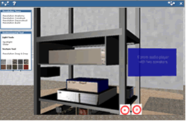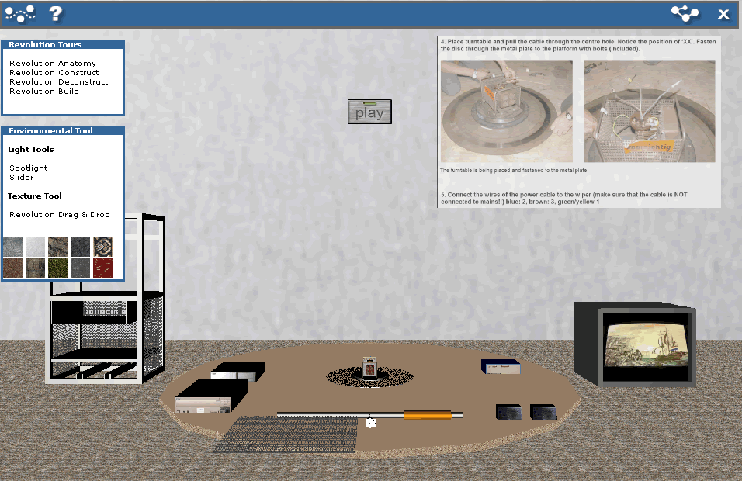
Figure 33. Detailed view artwork revolution Figure 34. Individual components
In short, the anatomy tour provides an automated exploration of the parts of the artwork, their material, position, connection and use. The construction tour provides an automated exploration of how the individual parts are installed and reversed represented by the deconstruction tour.
The manual construction test, allows for more user interactivity. The aim was to offer exhibitors a way to get familiar with the construction process of the artwork revolution in a virtual (that is safe) environment. Especially when confronted with delicate material parts that are hard to replace or cannot be replaced when broken. This tour guides the user through the process of construction by giving textual and visual feedback when manually constructing the artwork by its parts.
The tool environment also offers some manipulation of environmental parameters (e.g. light, textures) to indicate the effect it has on the exhibition, and as a consequence its experience, and can be related to the intent of the artist. (see figure 35 and 36)
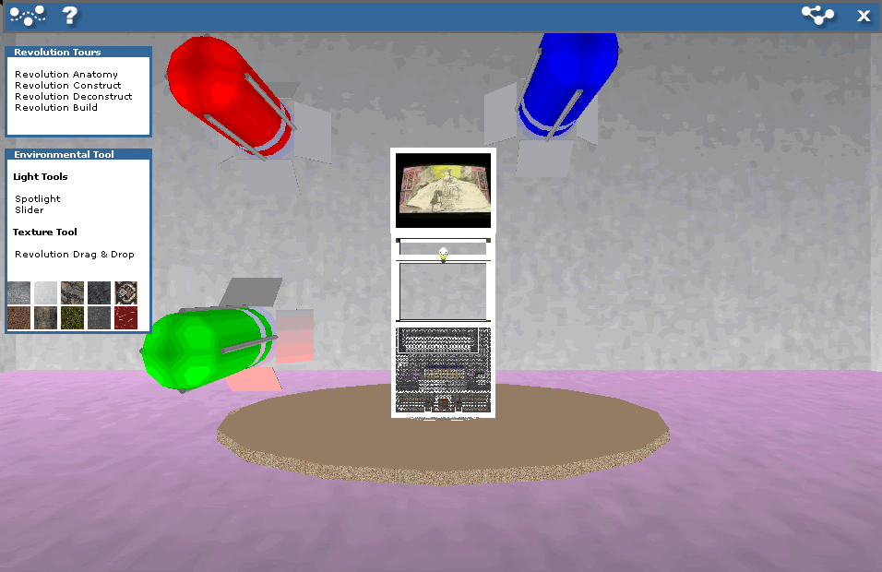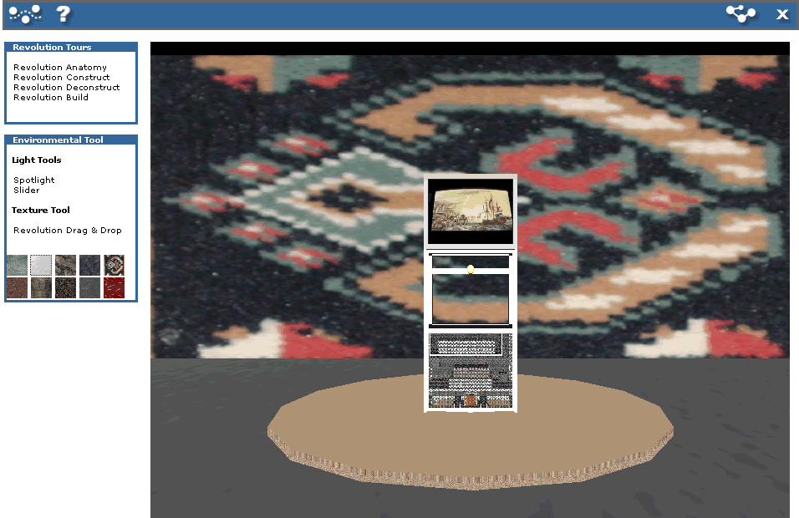
Figure 35. personalized environment of light Figure 36. personalized environment of texture
In the future, a tool environment as discussed could be improved by focusing on the artwork and its environment, which is part of the experience, allowing to extend the amount and degree of manipulating environmental parameters.
Chapter 8
Best practices in guided exploration – two case studies
Learning a craft 乾坤表里
Following the discussion of guided tours in chapter 7, we will explore the issue of personal guided exploration by looking at how two museums attempt to support their visitors in exploring their collections. We will look respectively at:
- tours provided by Musée du Louvre, to suggest interesting topics to the different visitor, and
- the way the Tate Modern Art Museum has re-organized its collection, to accommodate its visitors.
Finally, we will discuss a content-oriented approach to personalized guidance, setting out future research directions.
8.1 Tours at Musée du Louvre – users and interest
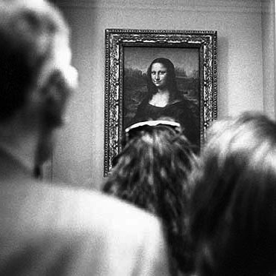
Figure 37. tours at Musée du Louvre
8.1.1 Normal tours
The insights of a national museum guide help visitors to rediscover the masterpieces, delve into a particular theme, or focus on one artist's œuvre. In Musée du Louvre, the guided tours are aimed at art enthusiasts and novices alike. [20]
The collections in the guided tours are classified in a traditional way, first by different user groups, and then by different topics.
First, let’s take a look at the directory of collections in the traditional guided tours. [20]
- Tours for individual adults
  - Discovery trails
  - Visits by Department or collection
  - Themed visits
  - "Monograph" tours
  - "An Hour at the Louvre"
  - Architectural trails
  - Temporary exhibitions
- Tours for children and families
  - Histories and Legends
  - Two by Two
  - The Medieval Louvre
  - Discovery Trail
- Tours for (individual/groups of) disabled visitors
  - for the visually impaired
  - using sign language
  - visitors in need of psychological support
- Tours for adult groups
- Tours for school and student groups
- Thematic gallery talks
Basically, this is a user need and user-centered design focused on the usability that considers user goals, characteristics and environment. It enables user to reach his/her goals effectively, comfortably and efficiently while interacting with collections from the museum. However, the user-centered approach also reveals drawbacks: pre-defined user criteria provide a solid framework for usability assessment, but lack flexibility in specific situations.
8.1.2 Special tour of the ‘Da Vinci Code’
Following the success of the book and film ‘Da Vinci Code’, Musée du Louvre started to provide a special tour to discover a soundwalk based on the Da Vinci Code story. It offers visitors a new way to experience the Louvre Museum. Through captivating narration by Jean Reno, listeners will literally re-trace and relive the intrigue of the Da Vinci Code. With music and sound clips from the Ron Howard film starring Tom Hanks and Audrey Tautou, Jean Reno brings the riveting mystery to life through commentaries on hypothesis and insights to this still-unfolding storyline. It take visitors to more than 30 masterpieces and through more than ten exhibition halls. [21]
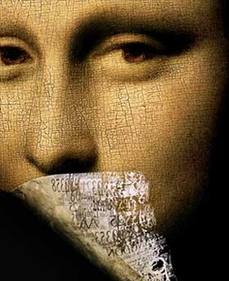
Figure 38. Da Vinci Code

The narrator Jean Reno
“I’m thrilled to be a part of helping people to experience one of France’s greatest treasures from this new perspective.”
Compared with the normal tours at the Musée du Louvre, the Da Vinci Code tour provides a different user experience based on the content in a story-telling way. Follow in the footsteps of Jean Reno, Captain Bézu Fache, as he takes you to the scene of the crime and into the heart of the Code.
8.2 Tate Modern Art Museum – new classification(s)
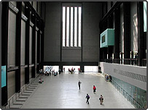
Figure 39. Tate Modern Art from BBC

Tate Modern holds the national collection of British art from 1500 and of international modern art. In these six years, Tate made a significant change to reorganize the classification of a huge amount of collections. It succeeded in drawing more visitors and improving visitor’s appreciation.
Here, let’s take a close look at the change about the classification of Tate collections.
The old classification scheme was based on the traditional categories and attributes from art history.
- Old historical or traditional classification
  - attributes from art history
    - style
    - period
    - artist
    - …
By was of experiment, a new classification scheme was introduced, as indicated below.
- New classification 1
  - The simple step is to use different classification without distinguish between visitors properties of contents theme-oriented instead of chronologically or style periods oriented.
  - 4 classes
    - Landscapes
    - Nudes
    - Still life
    - History
The new classification scheme was heavily criticized by the professionals, but received good feedback from visitors, and perhaps more importantly the new scheme had a positive effect on the number of visitors.
Yet, to accommodate the critics, yet another classification scheme was introduced, meeting the critics of the previous re-classification halfway.
- New classification 2
  - Combination or revision of the new classification reflects styles or –ismes
  - 4 updated classes
    - Poetry and Dream (from Landscapes/Matter/Environment)
    - Material Gestures (from Nude/Action/Body)
    - Idea and Object (from Still Life/Real Life/Object)
    - States of Flux (from History/Memory/Society)

According to the Volkskrant (june 2, 2006), the new classification actually reintroduces many of the familiar –ismes, namely there is a close relation between the above-mentioned categories and, respectively, kubisme and futurisme, surrealisme, abstract expressionisme and minimalisme.
It is instructive to include a fragment of that article verbatim:
from de Volkskrant (2/6/06)
Hannah Wellburn (31) wandelt met een vriendin en haar vierenhalve maand oude zoon Bobby in de kinderwagen door Tomoko Takahashi’s Tekenkamer (een chaos van junkmail, tekeningen en ander papier) in de Tate Modern. ‘Indrukwekkend’, mompelt ze. Ze woont in Londen en het is de vierde keer dat ze het museum bezoekt. ‘Of ik van moderne kunst hou? Eh, de mooiste kunst hier is het uitzicht vanuit de espressobar over de Theems op St. Paul’s. Maar ik ben het wel meer gaan waarderen. Voor 2000 hield ik eigenlijk alleen van Oude Meesters. Nu zie ik eigenlijk vaker moderne kunst.’
Veel Londenaren, maar ook heel veel toeristen, wippen even langs in Tate Modern op hun wandeling door Londen. Met kinderen, met familie of met wie dan ook. Het is gratis en altijd speciaal.
Tate Modern is een absolute voltreffer. Zelfs op woensdagmiddag is het chaotisch druk. ‘Ik wil dit niet druk noemen. Afgelopen weekeinde hadden we 100 duizend bezoekers’, zegt curator Achim Bochardt-Hume tijdens zijn rondleiding. Britse kranten schreven onlangs dat het museum aan zijn eigen succes ten onder dreigt te gaan. ‘Je doet het ook nooit goed. Als je geen mensen trekt, ben je elitair. Als het storm loopt, ga je weer aan je eigen succes ten onder’, moppert de curator. [22]
The success of Tate Modern indicates that reorganization of collections is feasible, and that, in other words, an alternative classification may enhance the users’ active appreciation of cultural heritage.
8.3 Reflection - a content-oriented approach
As a consequence of the foregoing, we would like to consider a content-oriented approach for the presentation of cultural heritage. By tradition, a user-oriented approach strives for realizing personalization primarily based on user profiles and user preferences. [23] A content-oriented approach involves, in contrast:
- First of all, the identification of concepts and relations within the combined cultural heritage content.
- Secondly, it aims to re-present the original attributes of artwork collections like wide diversity, complex relationship and traditional context in an attractive and clear way.
The content-oriented approach however can be made adaptive to different users according to their information-need. In other words, we regard the analysis of the content-attributes as a pre-condition for effective personalization. For instance, one interesting aspect of the second generation of digital dossier for the artist Jeffrey Shaw is the added function of filtering based on content-attributes and selection in the concept graph. It enables users to set up the dynamic hierarchy of concepts and select which information is to be presented. Furthermore, it provided the availability of a tool environment to learn about the construction and de-construction of the Revolution installation and to experiment with the exhibition space parameters of the artwork, such as the lighting conditions, and the color and texture of the walls and the floor. For future development, we believe that guidance in media-rich information must be applied implicitly - switching from exploration to guidance based on the preferences and information-need of the actual user. It is very likely to realize more personalization functions in static interfaces as well as in dynamic, narrative, interfaces based on the rich inter-related content and users’ information-need.
Chapter 9
Reproduction of art in the digital age
As if memories could deceive me 楼台远近
In this age with the Web ubiquitously within reach, at least in the Western world, what can we hope to achieve with making our cultural heritage available in a digital form? What is its potential, and what are the limitations?
In 1936, Walter Benjamin published the paper “The Work of Art in the Age of Mechanical Reproduction” which had profound influence on art-related research. In the paper, Benjamin discussed the issues of context of artworks. Key points are given below: [24]
- In principle a work of art has always been reproducible. Man-made artifacts could always be imitated by men.
- Mechanical reproduction of a work of art, however, represents something new. Historically, it advanced intermittently and in leaps at long intervals, but with accelerated intensity.
- Even the most perfect reproduction of a work of art is lacking in one element: its presence in time and space, its unique existence at the place where it happens to be.
- The presence of the original is the prerequisite to the concept of authenticity.
- The technique of reproduction detaches the reproduced object from the domain of tradition. By making many reproductions it substitutes a plurality of copies for a unique existence. And in permitting the reproduction to meet the beholder or listener in his own particular situation, it reactivates the object reproduced.
- Works of art are received and valued on different planes. Two polar types stand out; with one, the accent is on the cult value; with the other, on the exhibition value of the work.
- Mechanical reproduction of art changes the reaction of the masses toward art.
Compared with art reproduction in the mechanical age described in Benjamin’s paper, nowadays the digitization of media has greatly amplified this effect because digital reproduction is essentially cheaper, faster and more accurate than analog and mechanical means.
Digitized art becomes information: more data than object. Mechanical reproduction is often performed by an expert at or near to the manufacture of an object, whereas digital reproduction can be performed at any stage by anyone with a computer. Benjamin wrote that mechanical reproduction liberates art from its "parasitic dependence on ritual." Digital reproduction goes further: It liberates digital (both native digital and digitized analog) art from its dependence on commerce. However, this revolutionary potential is yet to be seen because of a concerted effort by the corporations who make up the culture industry. [25]
As observed by Benjamin, the reproducibility of art may also have an impact on the actual production of art. In accordance with this observation is the remark that: The cultural convergence of art, science, and technology provides ample opportunity for artists to challenge the very notion of how art is produced and to call into question its subject matter and its function in society. [26]
Therefore, it is important to identify relevant considerations in aesthetic, historical and conceptual significance. It related to the look and feel of visible components, relationship of the work to the process or technology employed and the spirit in which the work was made and the time period the work was made. [27]
However, where old and new media intersect and will come out later?
For instance, photographer Jerry de Wilde took a series of photos at New York, Amsterdam and Rome in 70s. (see figure 40) Although there is something from time immemorial, how can we represent the original scenario/context captured in the photos?
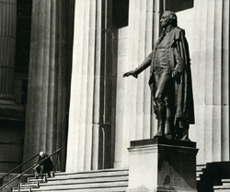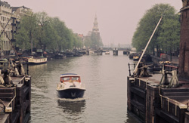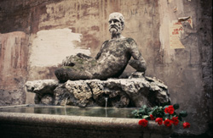
Figure 40. NYC 1965 : Amsterdam 1969 : Rome 1969
Although the presentation of our cultural heritage in a digital way is independent of the actual production of art, we must find was to present the art of the past in a way that respects this art, and the context in which the art originated. How? We leave that open to further research.
Chapter 10
Conclusion
I did it my way. 江汉西东
The master project of the abramovic dossier and related extensions had a twofold focus: implementation and research. As a consequence, this theis presents two results:
- The realization of a new tool to present art-related information
- Knowledge about research issues concerning the digital dissemination of cultural heritage.
In this thesis, we address a variety of aspects, including, with respect to the realization of the digital dossier, the explorative development of the dossier, using real 3D technology (VRML), the implementation of a concept map providing intuitive navigation, the simultaneous presentation of rich media content in a 3-window presentation gadget, and, moreover we showed how to combine navigation and presentation in an immersive way.
From the perspective of research, we discussed presentation issues, several variants of guided tours, case studies dealing with the actual practice of museum, on the basis of which we proposed a content-oriented approach to deal with issues such as personalization and user adaptivity.
In the field of cultural heritage, we face the situation that more and more data as well as precious objects and real materials increase everyday. The digitization solution provides ample opportunity to the general public because digital reproduction is essentially cheaper, faster and more accurate than any mechanical reproduction before. [25] However, although digitization liberates the artwork from its dependence on presence (time and space), it raises new issues like how to re-present the lost context in the digital world.
Immersion is undoubtedly a key to understanding of the development of the media, even though the concept appears somewhat opaque and contradictory. Immersion can be an intellectually stimulating process; however, in the present as in the past, in most cases immersion is mentally absorbing and a process, a change, a passage from one mental state to another. [28] No other concept seems more suitable to act as a guideline in presenting art to a wider audience.
Acknowledgements
We gratefully acknowledge the contribution of the following people to the development of the digital dossier:
- Vrije Universiteit Amsterdam: Eric de Boer, Pascal Snijders Blok, Olaf van Zon
- Universiteit van Amsterdam: Abeer Mahdi, Jina Menke, Michela Negrini
- Technische Universiteit Delft: Jurgen Koster
- The Netherlands Institute for Cultural Heritage: Tatja Scholte, Ijsbrand Hummelen
- Montevideo: Bart Rutten, Gaby Wijers

References

- All Chinese quotes from a Chinese poetry ‘Pu Tian Le, Chui Hong Ye Yue （普天乐， 垂虹夜月）’, from Zaisi Xu (徐再思) in Yuan dynastry（元朝）(1271－1368)
- Yoko Ono, Imagine Yoko, ISBN: 9177422368, Bakhall 2005
- Eliëns, A. Topical Media, syllabus Introduction Multimedia, http://www.cs.vu.nl/~eliens/media/
- Continuous Access To Cultural Heritage (CATCH), Netherlands Organisation for Scientific Research, 2004, http://www.nwo.nl/nwohome.nsf/pages/NWOP_66EUJ4_Eng/$file/EW%20CATCH%20programmatekst.pdf?openelement
- European Curriculum Reflections on Library and Information Science Education, the Royal School of Library and Information Science. Copenhagen 2005
- DigiCULT http://www.digicult.info
- ECHO http://echo2.mpiwg-berlin.mpg.de/home
- CHIOS http://www.ics.forth.gr/isl/projects/projects_individual.jsp?ProjectID=3
- COVAX http://www.covax.org/
- Jay David Bolter, Richard Grusin, Remediation, MIT Press, ISBN 0-262-02452-7, 2000
- SAS Publishing , Getting Started With Sas R 9.1.3 Open Metadata Interface, SAS Publishing, ISBN: 1590476077,Jun 1, 2004, chapter 1
- Canadian Heritage Information Network Standards Page: http://www.chin.gc.ca/English/Standards/metadata_intro.html
- A. Eliëns, Topical Media, Ch 10, http://www.cs.vu.nl/~eliens/media/10-3.html
- Eliëns A, van Riel C., Wang Y., Navigating media-rich information spaces using concept graphs - the abramovic dossier, accepted for: International Conference on Multidisciplinary Information Sciences and Technologies (InSciT2006), October, 2006, Mérida, Spain
- Schonhage, B., van Ballegooij, A., Eliëns, A. – 3D gadgets for business process visualizations, Proceedings of the fifth symposium on Virtual reality modeling language (Web3D-VRML), 131 - 138, Monterey, California, United States, February 2000.
- Robertson, G., Mackinley, J. & Card, S., Cone trees: animated 3D visualizations of hierarchical information, Proceedings of the SIGCHI conference on Human factors in computing systems, United States, March 1991.
- Wang Y., Eliëns A., van Riel C., Content-oriented presentation and personalized interface of cultural heritage in digital dossiers, accepted for: International Conference on Multidisciplinay Information Sciences and Technologies (InSciT2006) October, 25-28th 2006, Mérida, Spain
- van Riel C., Eliëns A., Wang Y., Exploration and guidance in media-rich information spaces: the implementation and realization of guided tours in digital dossiers, accepted for: International Conference on Multidisciplinary Information Sciences and Technologies (InSciT2006), October, 2006, Mérida, Spain
- Hoorn J., Eliëns A., Huang Z., van Vugt H.C., Konijn E.A., Visser C.T. (2004), Agents with character: Evaluation of empathic agents in digital dossiers, Emphatic Agents, AAMAS 2004 New York 19 July - 23 July, 2004.
- Musée du Louvre http://www.louvre.fr/llv/activite/liste_evenements.jsp?nature=activite_nature_1&bmLocale=en
- Da Vinci Code Soundwalk from the Musée du Louvre http://musee.louvre.fr/audioguide/en/about_en.html
- Nieuws from de Volkskrant http://www.volkskrant.nl/kunst/article316120.ece/Tate_Modern_is_teruggekeerd_naar_de_-ismen
- Dix A, FInaly J, Abowd G, Beale R, Human Computer Interaction, second edition, 2001
- Walter Benjamin, the Work of Art in the Age of Mechanical Reproduction, 1936
- The Work Of Art in the Age of Digital Reproduction http://www.aphid.org/epiphany/index.php/WorkOfArtInTheAgeOfDigitalReproduction
- Stephen Wilson, Information Arts: Intersections of Art, Science, and Technology, The MIT Press Cambridge, Massachusetts, 2002, ISBN 0-262-23209-X
- Digitisation of European Cultural Heritage Products-Principles-Techniques http://www.cs.uu.nl/events/dech1999/dech.htm
- Oliver Grau, Virtual Art: from illusion to immersion, ISBN 0-262-07241-6, Series Foreword, p13
- Dublin Core Metadata Initiative (DCMI) Glossary http://dublincore.org/documents/usageguide/glossary.shtml#D
Appendix – to my dear Chinese readers

从90年代以来，文化遗产的数字化已经变成了一个重要的先决条件来推动艺术学院、美术馆和大众之间的远距离的合作、教育以及旅游等活动。我在荷兰阿姆斯特丹自由大学的研究生毕业项目就是在这样一个大背景下开始的。

2004 年秋天，在导师 Anton Eliens 的指导下，我和其他8个学生作为一个多媒体小组，开始为阿姆斯特丹的两个文化及媒体学院（The Netherlands Institute for Cultural Heritage和The Netherlands Media Art Institute）设计和实施一个工具，用来在网上展示活跃于70年代的行为艺术家 Marina Abramovic的作品，包括图片、文字、录像、装置等不同类型的作品。

为了区别于普遍流行的在2维平面内实现的做法，我们试着探索、设计一个3维的数字档案 （digital dossier）用来导航和展示艺术家 Abramovic 的大部分作品。总的来说，这个数字档案较好的实现了以下三个功能：
- 利用概念图（concept graph），有效地连接各种作品相关的信息，提供动态导航
- 在3个窗口同时展示不同的信息内容，并展示这些信息之间的关系
- 为避免用户迷失在容量大且关系复杂的信息中，提供一个个性化的导览（guided tour）帮助

我们按照现实作品的原貌，创建了许多逼真的3维模型，这使整个数字档案有一个非常直接、生动的概貌，不但能提供具体的信息内容，还能反映信息彼此之间错综复杂的相互关系。同时，我们设计了一个拥有3个窗口的展示平台，它最大化的满足了用户想在同一时间看很多信息的需求，同时也尽量避免了对多种信息同时展示的扭曲。

除此之外，我们还做了一些数字档案的相关衍生产品。比如，我们设计了一个针对美术馆管理人员的在线内容管理工具（online content management tool）。用户不需要对数字档案进行编程，而是通过直接提交现有的艺术品的数据，自动转化生成数字档案所需的编码，以更新其动态信息结构。 所有这些相关信息都可以在我们的项目网站上找到， 请查看 www.few.vu.nl/~dossier05。

作为一个实验性的项目，虽然在可用性上还有很大的空间去改进，但整个3维数字档案展示艺术品的设计想法还是有其独特的创新之处。在学术研究上，针对不同的方面，我们发表了4片论文讨论诸如导航（navigation）、展示（presentation）和导览（guided tours）的问题；同时，我们也得到了来自美术馆、文化媒体机构的专业用户的支持和肯定。

跨过地域和文化的差异，作为一个新的方法，3维数字档案是否也可以用来把中国美术馆里那些分散的艺术品连接起来，并生动活泼的展示出来呢？我们的大众是否接受并喜欢这样一个全新的方式呢？这些开放的问题，我们留作以后的探索和研究。

王依文

阿姆斯特丹，荷兰
7月31日，2006年

ICN (The Netherlands Institute for Cultural Heritage) http://www.icn.nl
Montevideo (The Netherlands Media Art Institute) http://www.montevideo.nl
INCCA (International Network for the Conservation of Contemporary Art) http://www.incca.org
Casus 2004 spring - Dossier Boezem http://www.few.vu.nl/~casus04/
Casus 2004 autumn - the abramovic dossier http://www.few.vu.nl/~dossier05
Casus 2005 fall - Dossier Shaw http://www.few.vu.nl/~casus05
G7 (G-7 Ministerial Conference on the Global Information Society), Brussels, Feb 25-26, 1995
ISAD (Information Society and Developing Countries Conference), Midrand, May 1996
ECHO (European Cultural Heritage Online) http://echo2.mpiwg-berlin.mpg.de/home
European Cultural Heritage Online (ECHO) http://echo2.mpiwg-berlin.mpg.de/home/project/pilotphase
CATCH (Continuous Access to Cultural Heritage) http://www.nwo.nl/nwohome.nsf/pages/NWOP_5XSKYG
http://www.inside-installations.org/
‘Everything is intertwinkled.’ from Ted Nelson (1980)
From Reel123 http://www.reel23.com/
From Reel123 http://www.reel23.com/
Marina Abramovic’s performance: Art must be Beautiful, Artist must be Beautiful (Copenhagen, Denmark, 1975)
http://www.limsi.fr/Individu/jacquemi/IRI-TR/visu-inter2.jpg
Mariano Maturana’s artwork: Welcome to Amsterdam (1994)
Artwork: As if memories could deceive me, from Marcel Odenbach (1986)
photographer Jerry de Wilde http://www.dewildephotography.com/
English lyrics of the song ‘My Way’ from Paul Anka

